**A/B Testing in Python DataCamp**

**Overview of A/B Testing**

**3. Data Processing, Sanity Checks, and Results Analysis**

**

**A/B test data cleaning**

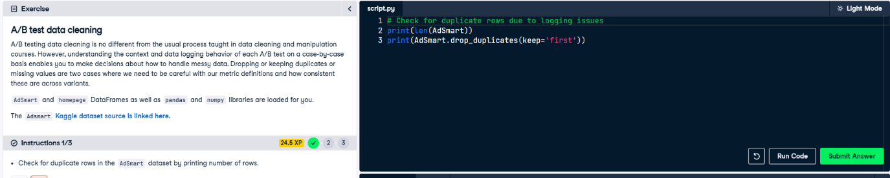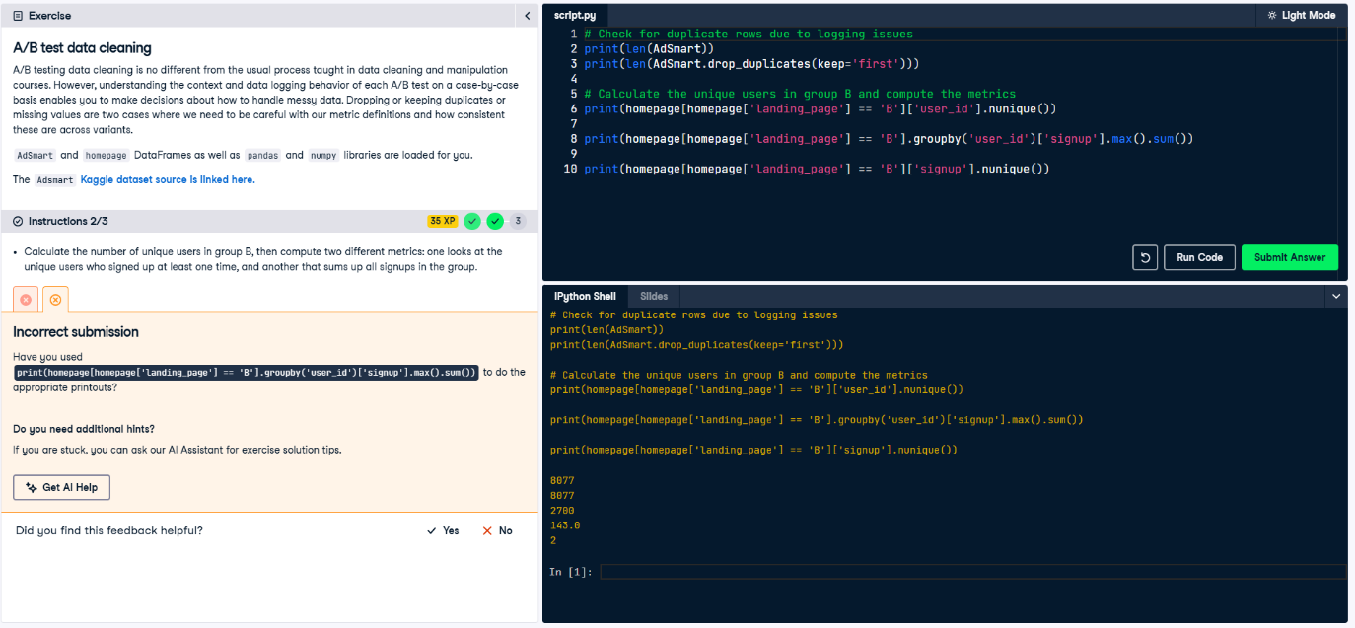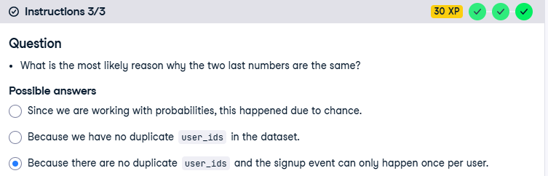

**SRM**

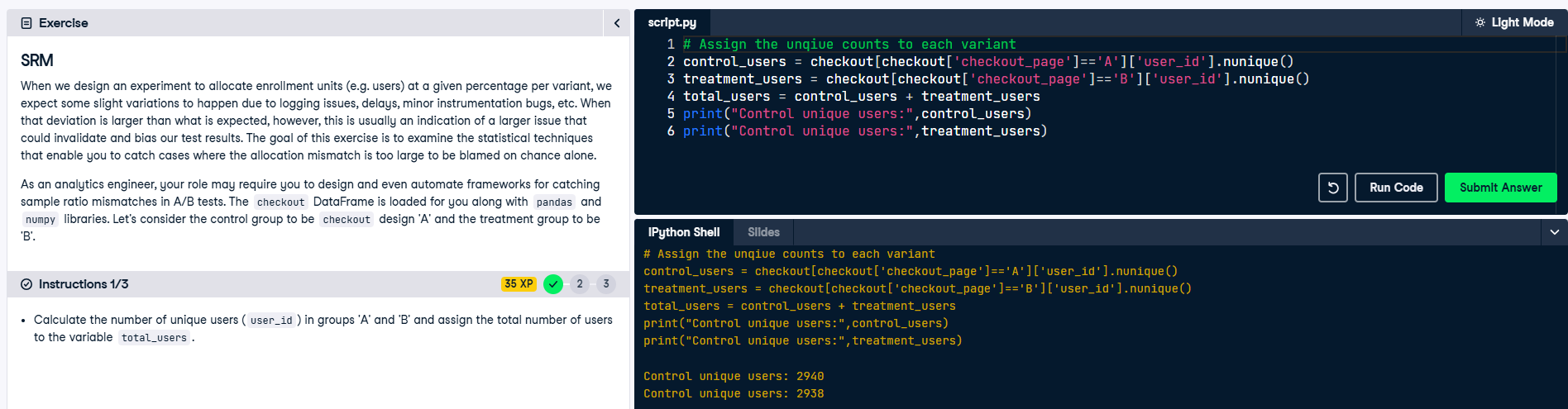

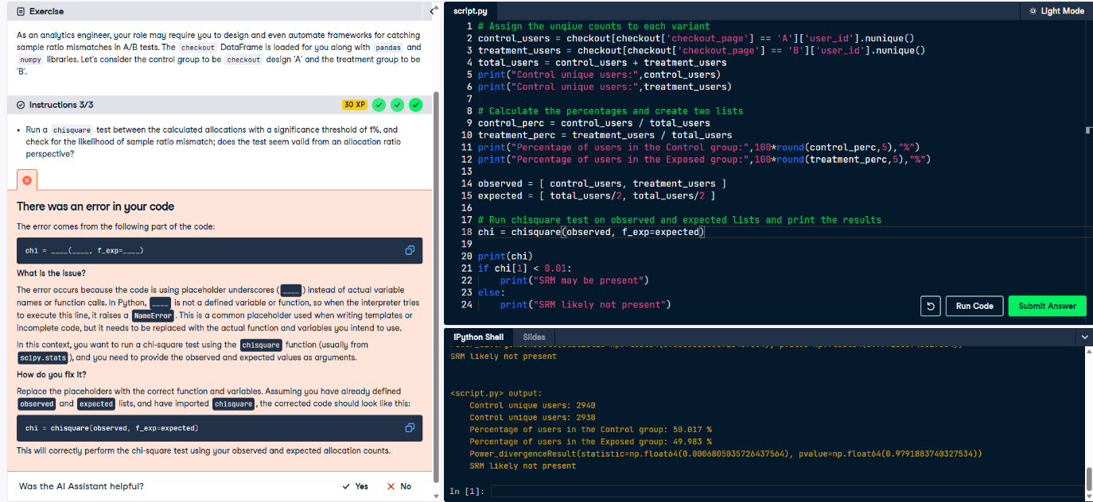

**Distributions balance**

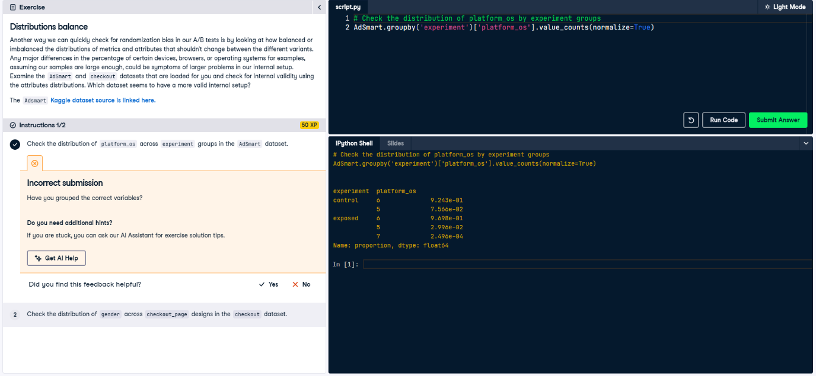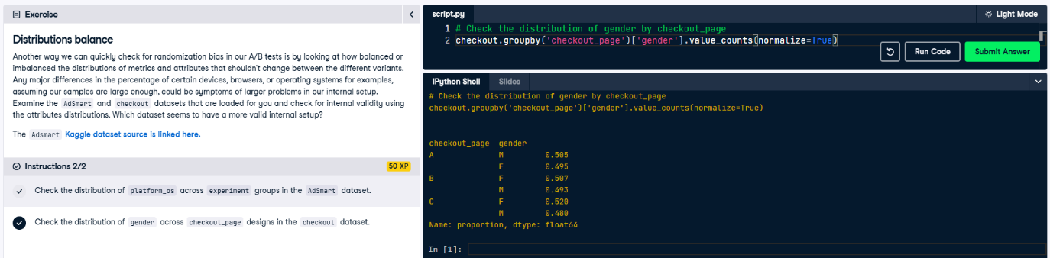

**Novelty effects detection**

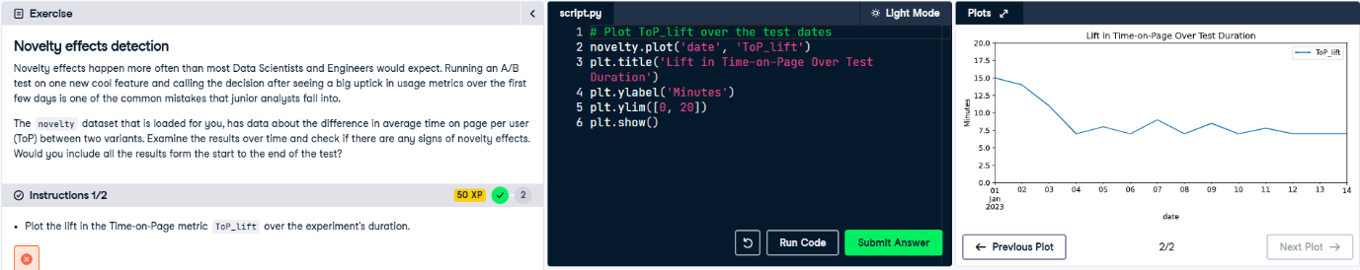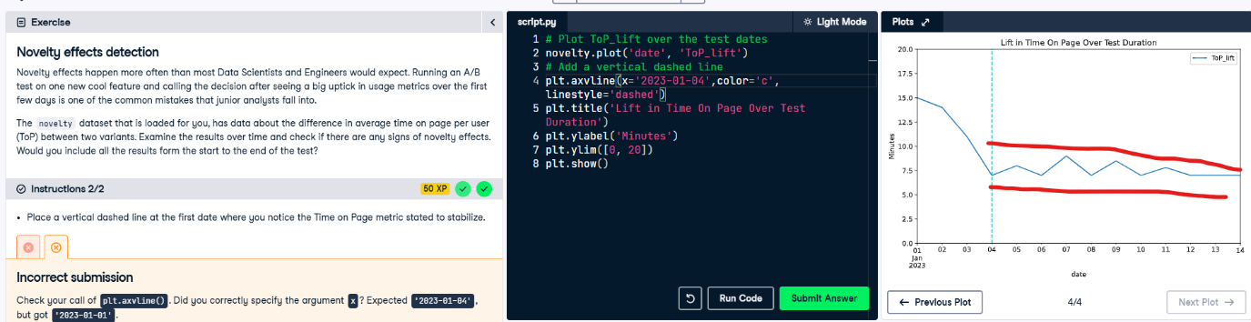

**Simpson’s paradox in action**

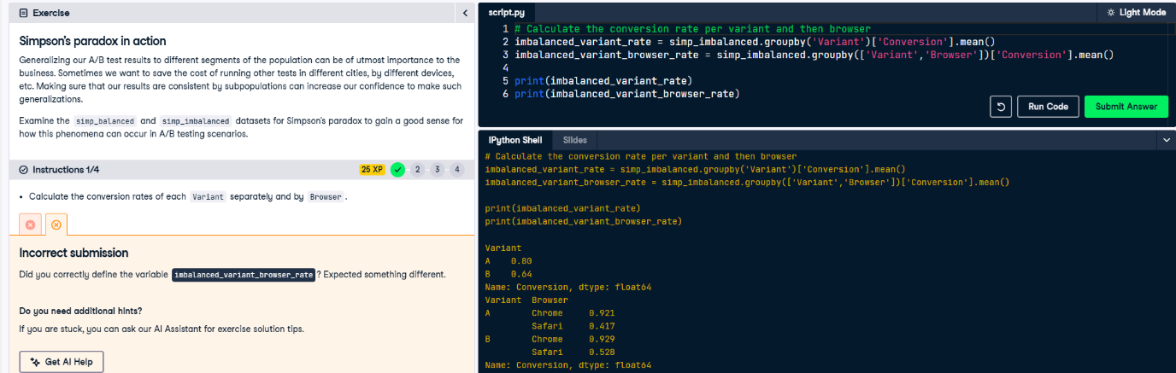

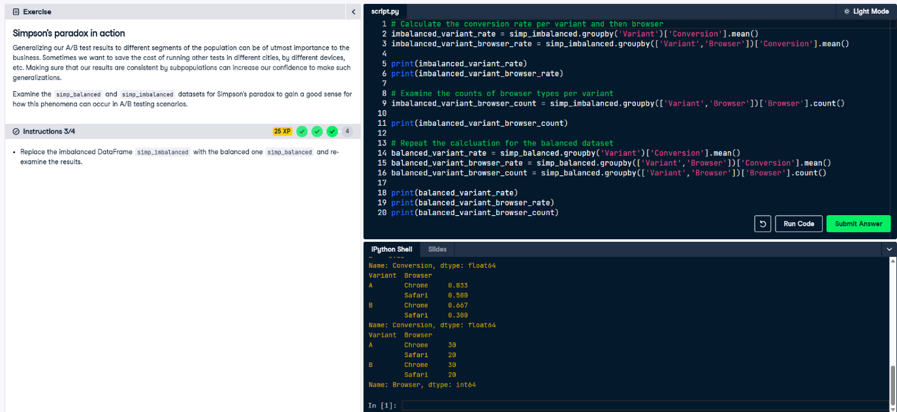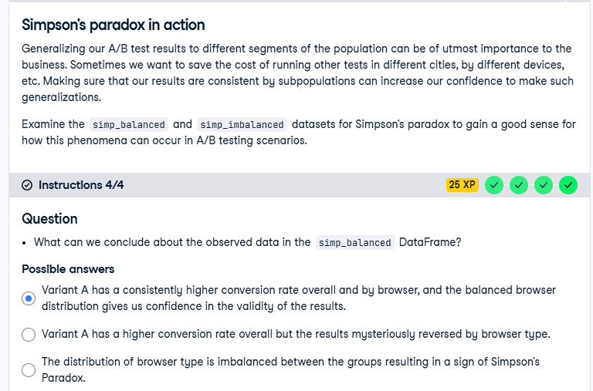

**Difference in proportions A/B test**

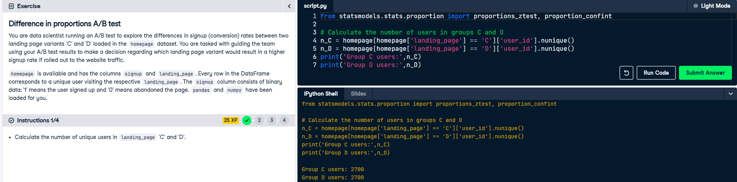

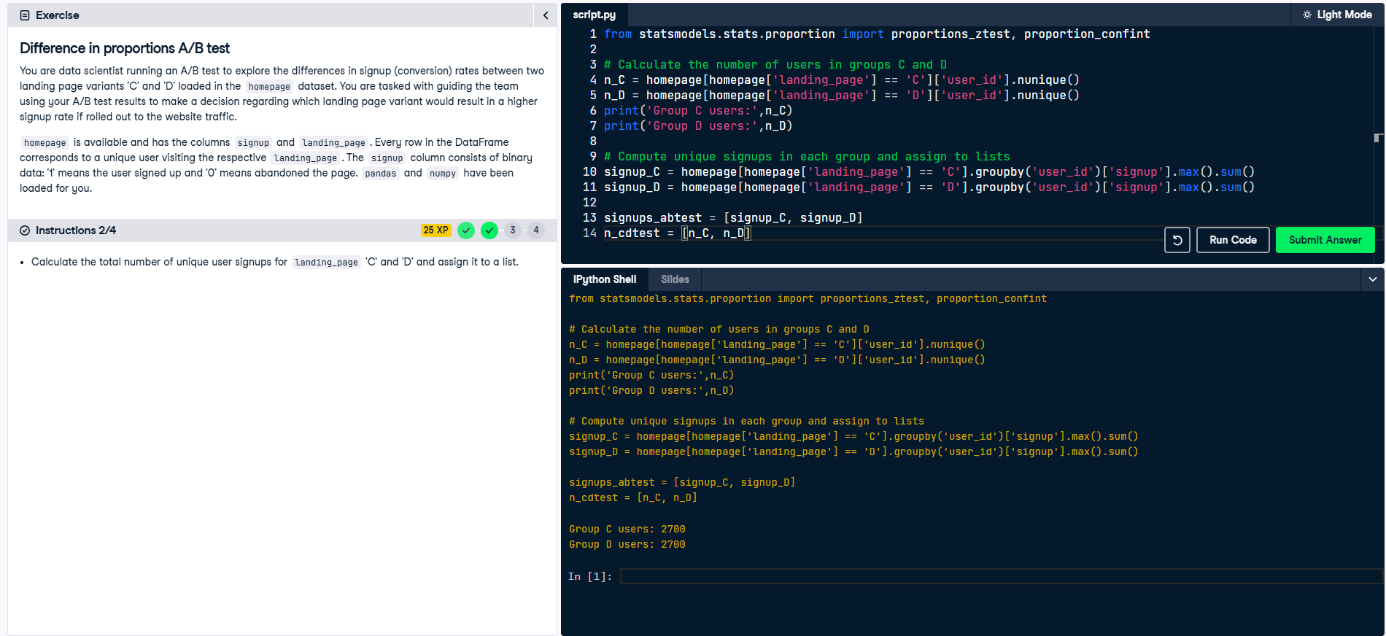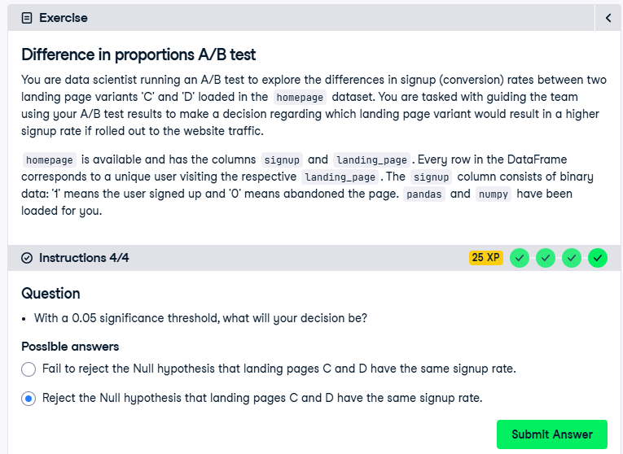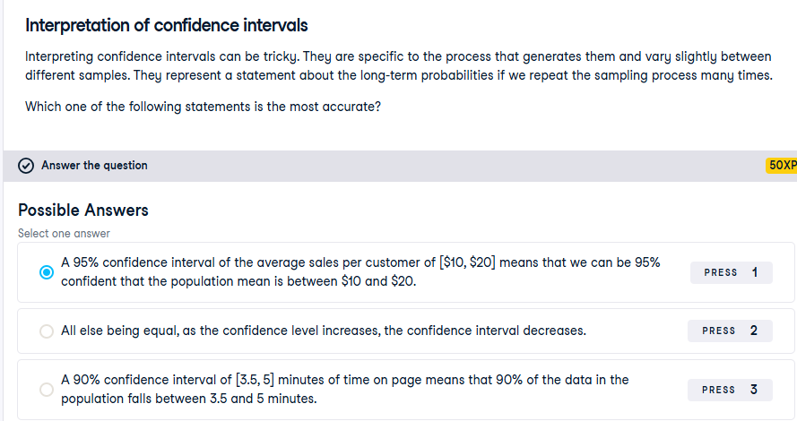

**Confidence intervals for proportions** 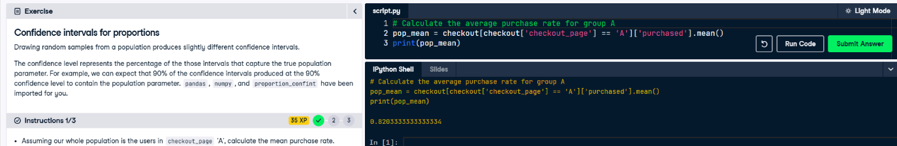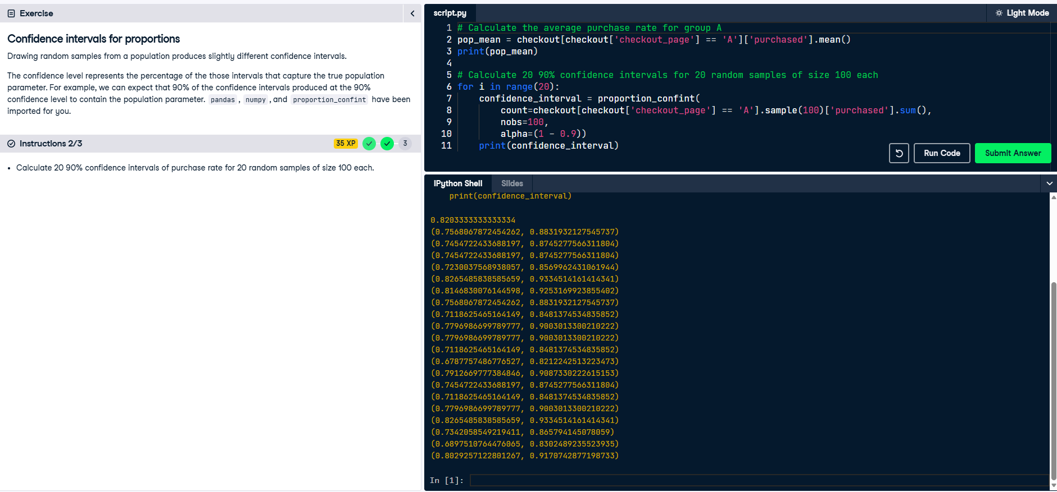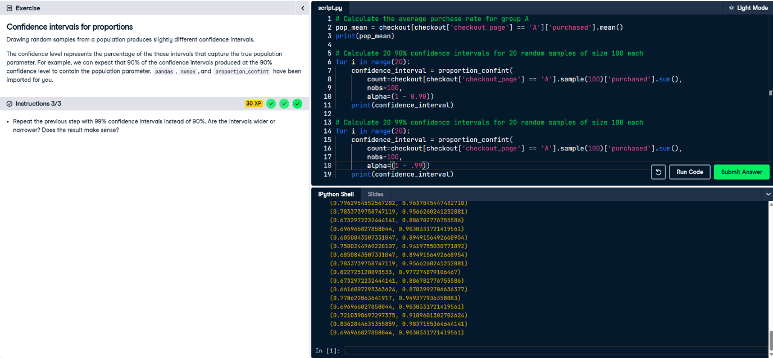

**4. Practical Considerations and Making Decisions**

**T-test for difference in means**

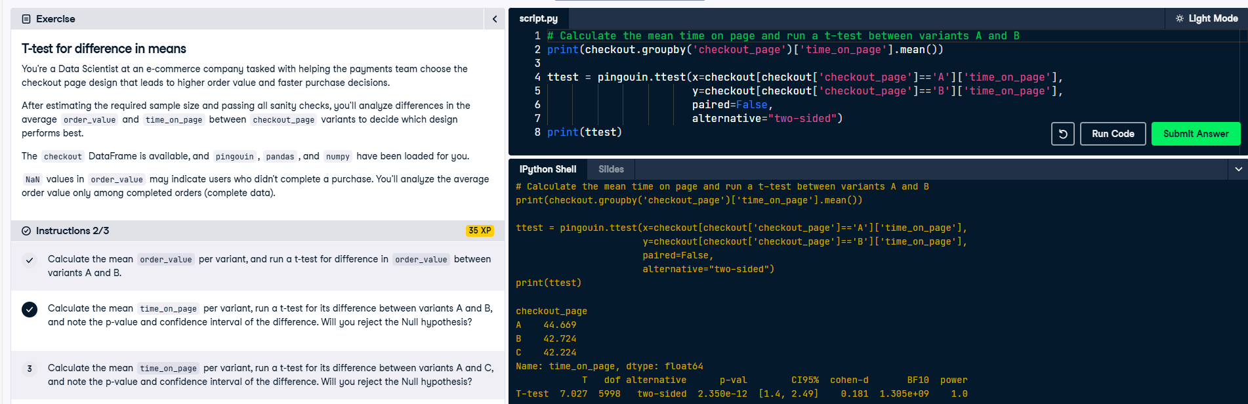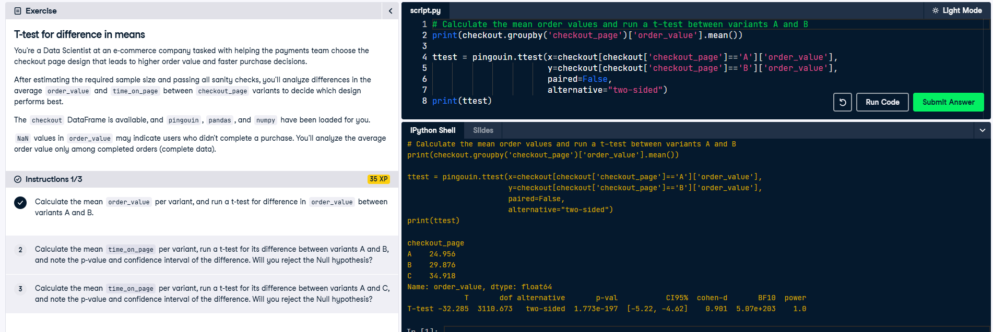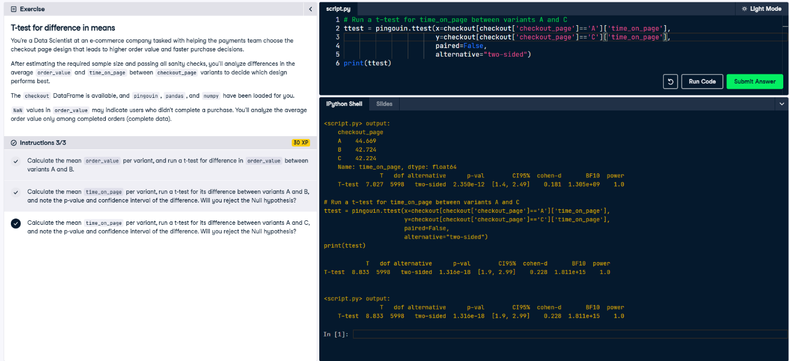

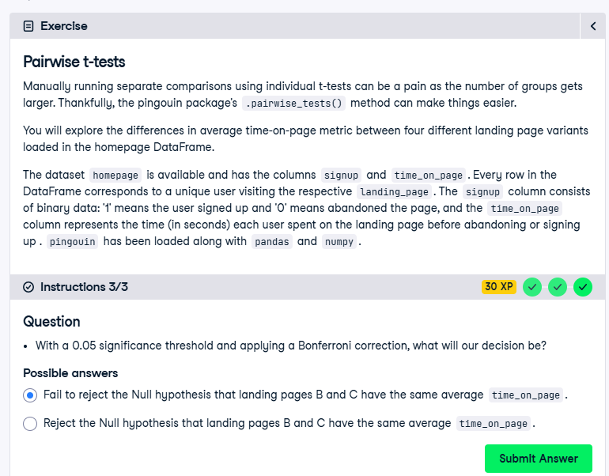

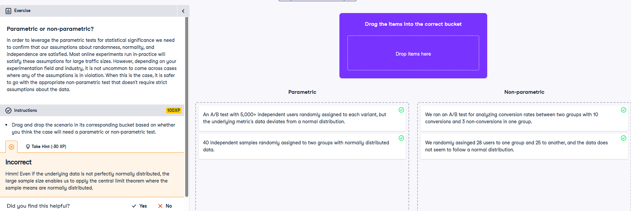

**NOTE: It is parametric if it is assigned to each variant.**

**Mann-Whitney U test**

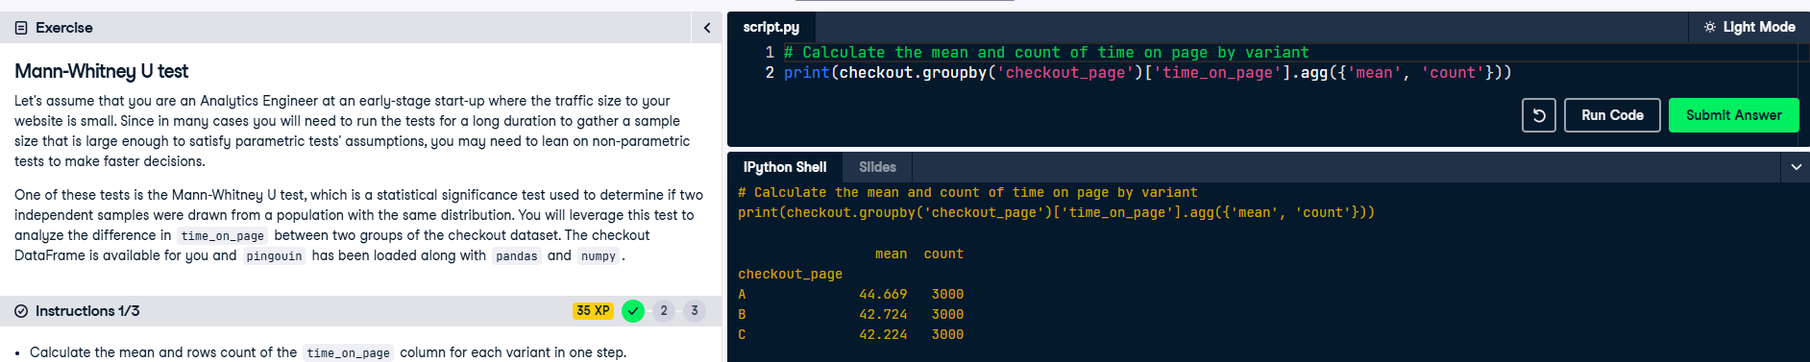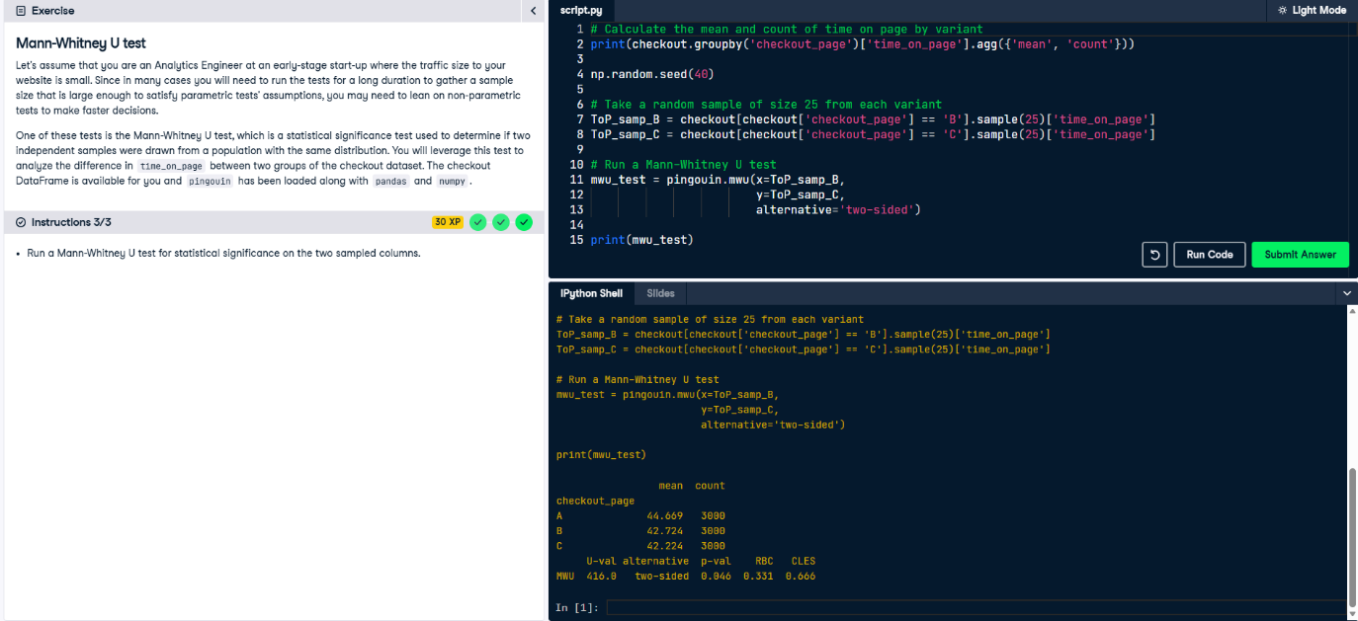

**Chi-square test for independence**

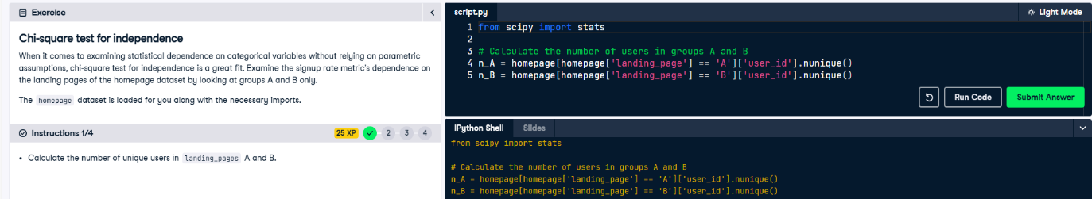

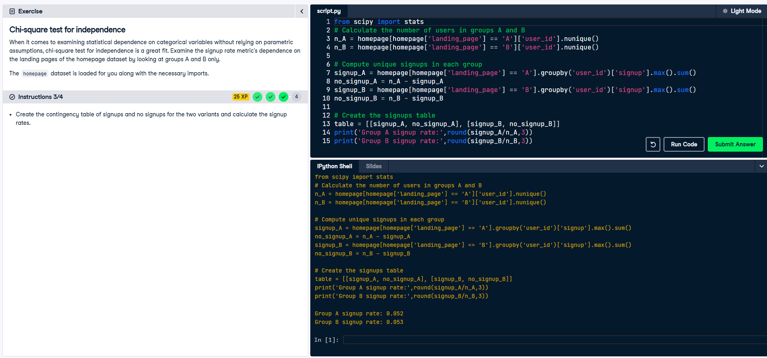

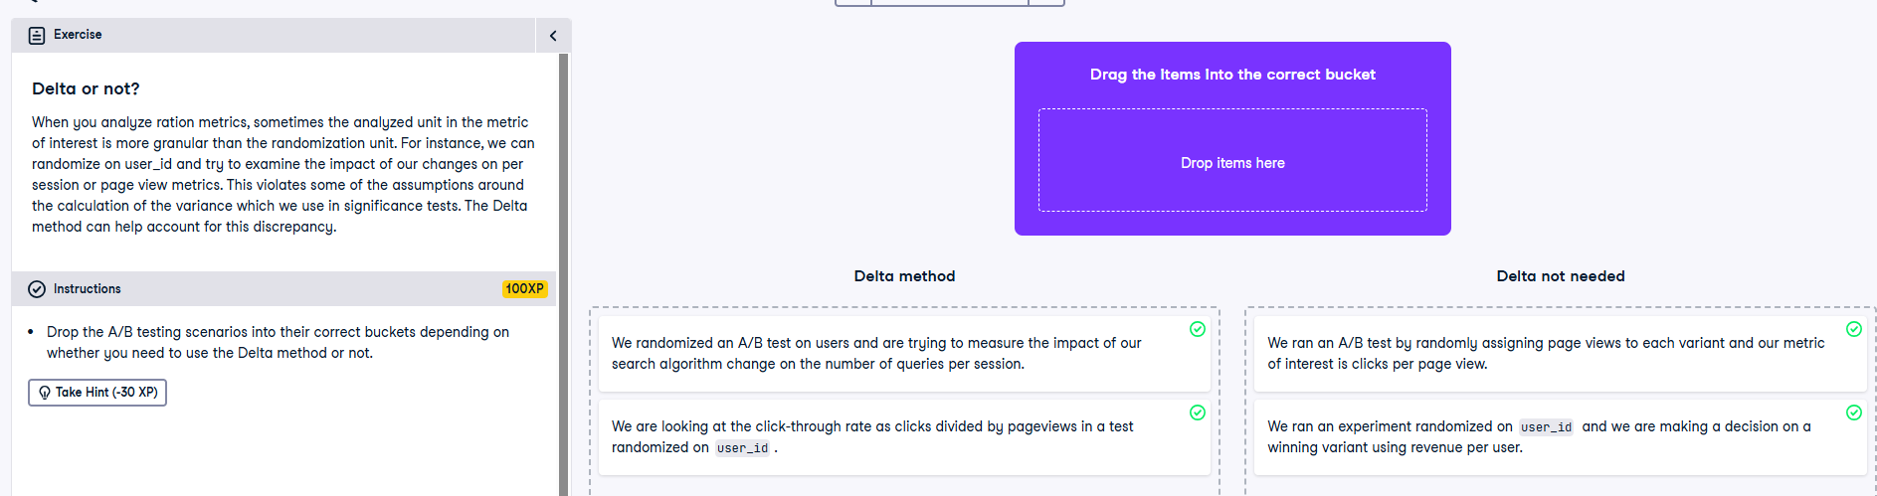

**Delta method**

